Jason S. Heo Investments

202278520 GSF2022

**Empirical Assignment**

1. **Selecting 10 stocks from the Korean stock market**

Stocks were selected based on one specific criteria, i.e., well performing stocks within the solar industry. This theme was chosen based on the idea that ESG factors being supported are likely to outperform the broad market. More precisely, it is focused on the time when the Korean President announced support for the solar energy industry to remove reliance on nuclear energy. The firms chosen offer variety of products such as displays, semiconductor chips, and materials for batteries. However, main reason for including these stocks for this research were for their involvement in the solar energy space, such as the solar battery technology and solar panels. The chosen stocks are listed below.

* 나노신소재
* 대성파인택
* 대주전자재료
* 아바코
* 알에스오토메이션
* 주성엔지니어링
* 주식회사케이씨씨
* 코미코
* 한화소루션보통주

1. **Collecting each stock’s daily return data**

Data for the 10 stocks were collected using the TS2000 application. The price data retrieved were then transformed into daily simple daily returns (log returns were purposely not chosen for this experiment) using the following formula.



The bar chart below plots all the daily returns overlapped on each other to check for skewness in the positive direction, as the purpose is to seek stocks with positive returns.

The graph seems to suggest that positive returns heavily outweigh negative returns distribution overall.

1. **Calculating the mean and variance of returns and constructing the variance-covariance matrix from the collected data**

The calculated daily mean returns for each stock also confirmed to be positive for all. This is an important observation because we are assuming the mean return of a stock is the proxy for expected return of that stock for the purpose of this research.

|  |  |
| --- | --- |
| Stock | Mean Return |
| 나노신소재 | 0.004757 |
| 대성파인텍 | 0.002192 |
| 대주전자재료 | 0.003695 |
| 신성이엔지보통주 | 0.002707 |
| 아바코 | 0.001824 |
| 알에스오토메이션 | 0.002266 |
| 주성엔지니어링 | 0.003249 |
| 주식회사케이씨씨 | 0.002001 |
| 코미코 | 0.002298 |
| 한화솔루션보통주 | 0.002515 |

Next step, the variance of each stock were calculated to start constructing the variance-covariance matrix.

|  |  |
| --- | --- |
| **Stock** | **Daily Variance** |
| 나노신소재 | 0.001786 |
| 대성파인텍 | 0.002075 |
| 대주전자재료 | 0.001431 |
| 신성이엔지보통주 | 0.001855 |
| 아바코 | 0.001010 |
| 알에스오토메이션 | 0.001167 |
| 주성엔지니어링 | 0.001102 |
| 주식회사케이씨씨 | 0.000964 |
| 코미코 | 0.001006 |
| 한화솔루션보통주 | 0.000992 |

Finally, the full covariance matrix is shown below.

As a bonus, the correlation matrix can be constructed to help see the directional relationship between them.

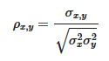

1. **Efficient Frontier**

Getting to the main point of this paper, we will first show the Markowitz Efficient Frontier by building portfolios with random weight assigned to each stock, draw the efficient frontier line by using the optimization function, and finally mark the maximum Sharpe ratio portfolio (tangent portfolio) and the global minimum variance portfolio (GMVP). The graph and the general optimization function is as follows.

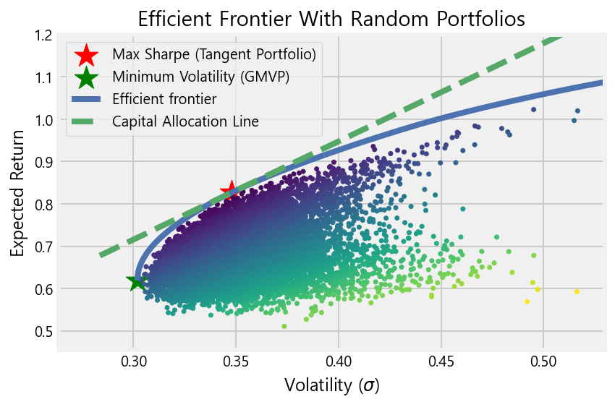

The capital allocation line (CAL) is also drawn as a dashed line with a risk-free rate assumption of 2%. As we can see, the frontier curve forms a semi-hyperbole shape, and connecting below the GMVP would show the full frontier as a hyperbole.

The resulting expected return, expected volatility, Sharpe ratio, and the weight allocations to each stock is suggested from the optimization for both Tangent Portfolio and the GMVP.

**Maximum Sharpe Ratio Portfolio Allocation (Tangent Portfolio)**

Expected annual return : 82.7%

Annual volatility : 34.8%

Sharpe Ratio : 2.32

|  |  |
| --- | --- |
| **Weights for each stock** | |
| 나노신소재 | 0.25659 |
| 대성파인텍 | 0.0 |
| 대주전자재료 | 0.08883 |
| 신성이엔지보통주 | 0.0848 |
| 아바코 | 0.0 |
| 알에스오토메이션 | 0.0304 |
| 주성엔지니어링 | 0.26275 |
| 주식회사케이씨씨 | 0.13478 |
| 코미코 | 0.09001 |
| 한화솔루션보통주 | 0.05184 |

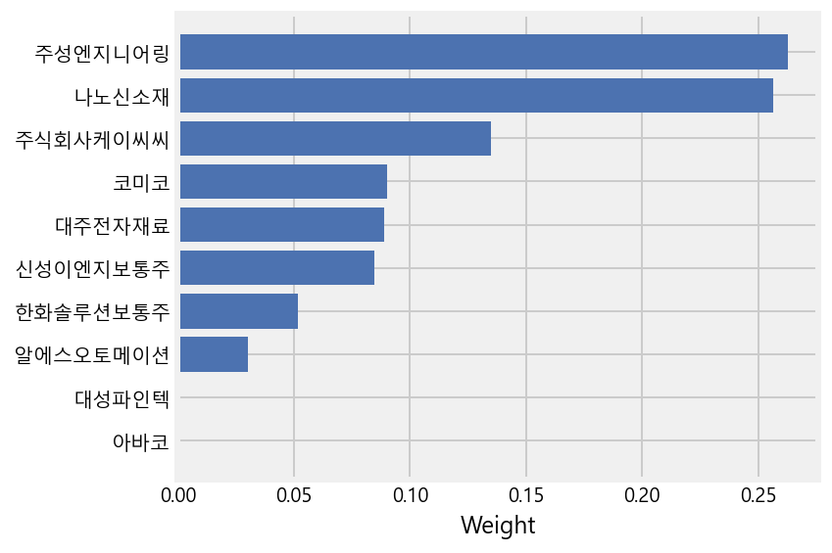

**Minimum Volatility Portfolio Allocation (GMVP)**

Expected annual return : 61.9%

Annual volatility : 30.2%

Sharpe Ratio : 1.99

|  |  |
| --- | --- |
| **Weights for each stock** | |
| 나노신소재 | 0.04246 |
| 대성파인텍 | 0.0066 |
| 대주전자재료 | 0.06083 |
| 신성이엔지보통주 | 0.04912 |
| 아바코 | 0.14443 |
| 알에스오토메이션 | 0.09256 |
| 주성엔지니어링 | 0.09036 |
| 주식회사케이씨씨 | 0.22594 |
| 코미코 | 0.18017 |
| 한화솔루션보통주 | 0.10753 |

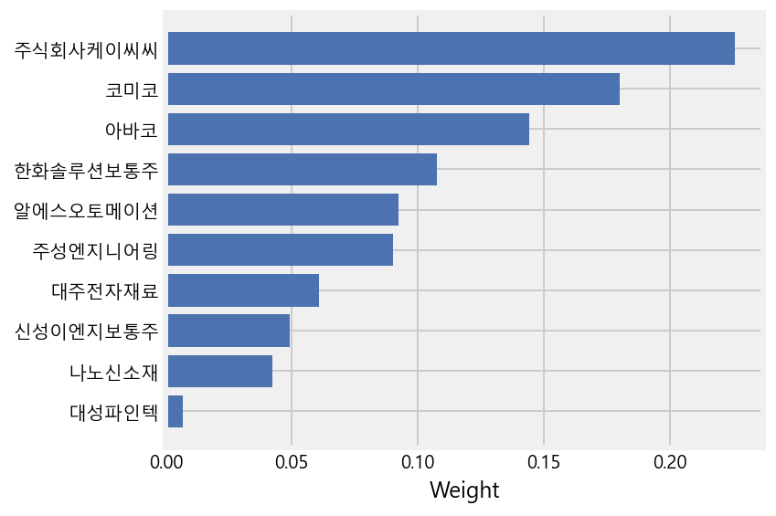

The annualized expected return and Sharpe ratios for both tangent portfolio and GMVP look extremely attractive. However, it should be noted that these stocks were chosen with “known” historical returns that is being used as proxy for the expectations. In other words, there exists heavy survivorship bias embedded in the selection process.

1. **Optimal Portfolio Construction**

The final experiment is to construct the optimal portfolio given risk-free rate, risk aversion level, and a utility function.

R f = 2%

With slope of indifference curve = Aσ =Ay∗σT and slope of CAL E(RT)−RfσT We can obtain for y∗ which is the weight of tangent portfolio in final optimal portfolio given parameter "A".

Risk Aversion Parameter : **A = 50**

Portfolio Expected Return : 0.12756

Portfolio Variance : 0.01614

Portfolio Standard Deviation : 0.12704

Tangent Portfolio Weight : 0.13329

Risk Free Asset Weight : 0.86671

\***Investment Weights for Each Stock**\*

나노신소재 : 0.034

대성파인텍 : 0.0

대주전자재료 : 0.012

신성이엔지보통주 : 0.011

아바코 : 0.0

알에스오토메이션 : 0.004

주성엔지니어링 : 0.035

주식회사케이씨씨 : 0.018

코미코 : 0.012

한화솔루션보통주 : 0.007

Risk Aversion Parameter : **A = 100**

Portfolio Expected Return : 0.07378

Portfolio Variance : 0.00807

Portfolio Standard Deviation : 0.08983

Tangent Portfolio Weight : 0.06665

Risk Free Asset Weight : 0.93335

\***Investment Weights for Each Stock**\*

나노신소재 : 0.017

대성파인텍 : 0.0

대주전자재료 : 0.006

신성이엔지보통주 : 0.006

아바코 : 0.0

알에스오토메이션 : 0.002

주성엔지니어링 : 0.018

주식회사케이씨씨 : 0.009

코미코 : 0.006

한화솔루션보통주 : 0.003

Risk Aversion Parameter : **A = 200**

Portfolio Expected Return : 0.04689

Portfolio Variance : 0.00403

Portfolio Standard Deviation : 0.06352

Tangent Portfolio Weight : 0.03332

Risk Free Asset Weight : 0.96668

\***Investment Weights for Each Stock**\*

나노신소재 : 0.009

대성파인텍 : 0.0

대주전자재료 : 0.003

신성이엔지보통주 : 0.003

아바코 : 0.0

알에스오토메이션 : 0.001

주성엔지니어링 : 0.009

주식회사케이씨씨 : 0.004

코미코 : 0.003

한화솔루션보통주 : 0.002

To conclude, in the case of optimal portfolios, the observed allocation shows, the higher the risk aversion level, the less allocations are made to the Tangent Portfolio to lower the expected volatility. Consequently, weights suggested for each stock is lowered as a result. However, the attractive quality of this type of portfolio construction method, appears to be the ability to match an investor’s risk management objective. Simply by shifting weights between the best rewarding risky portfolio and the risk-free asset, we can increase or decrease expected volatility of the optimal portfolio and in return expect to be rewarded accordingly depending on the structure of our portfolio.